**STEPS TO RUN THE CODE:**

* **REQUIREMENTS:**
* Python 3.7 version
* Python libraries:
* from sklearn import tree
* from sklearn.svm import SVC, LinearSVC
* from textblob import TextBlob
* from nltk.corpus import twitter_samples
* from tkinter import filedialog, messagebox, simpledialog
* import matplotlib.pyplot as plt
* import pandas as pd
* import numpy as np
* import re, string

* Also initialize **NLTK resources** (if not downloaded yet):
* import nltk
* nltk.download('twitter_samples')
* nltk.download('stopwords')
* nltk.download('punkt')
* nltk.download('wordnet')
* nltk.download('omw-1.4')
* Folder structure:

project_folder/

├── your_script.py

├── dataset/

│ ├── train_tweets.csv

│ └── test_tweets.csv

└── test/

└── test_tweets.txt # for manual detection (optional)

* **STEPS :**

1. Open “Sentiment analysis” folder and click on “RUN THE CODE”.

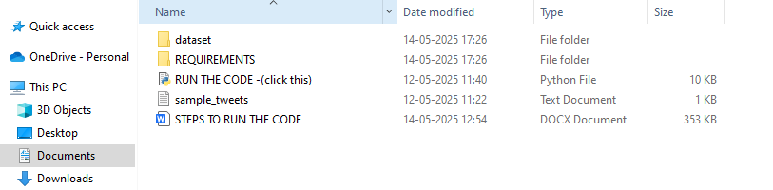

1. The following GUI interface will open. Click on the “load NLTK dataset” button.

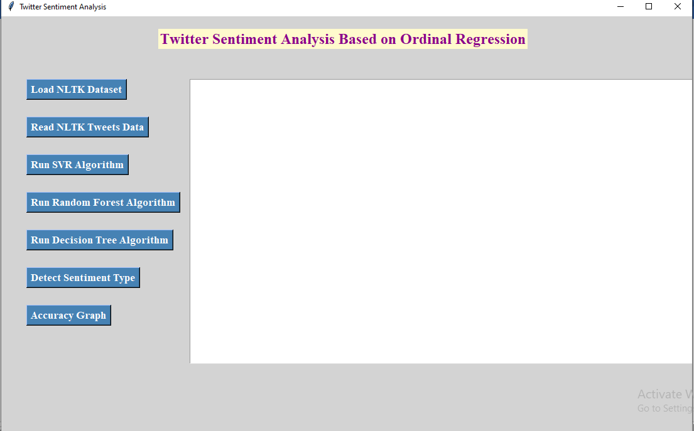

1. After loading NLTK dataset click on “run SVR algorithm” button.

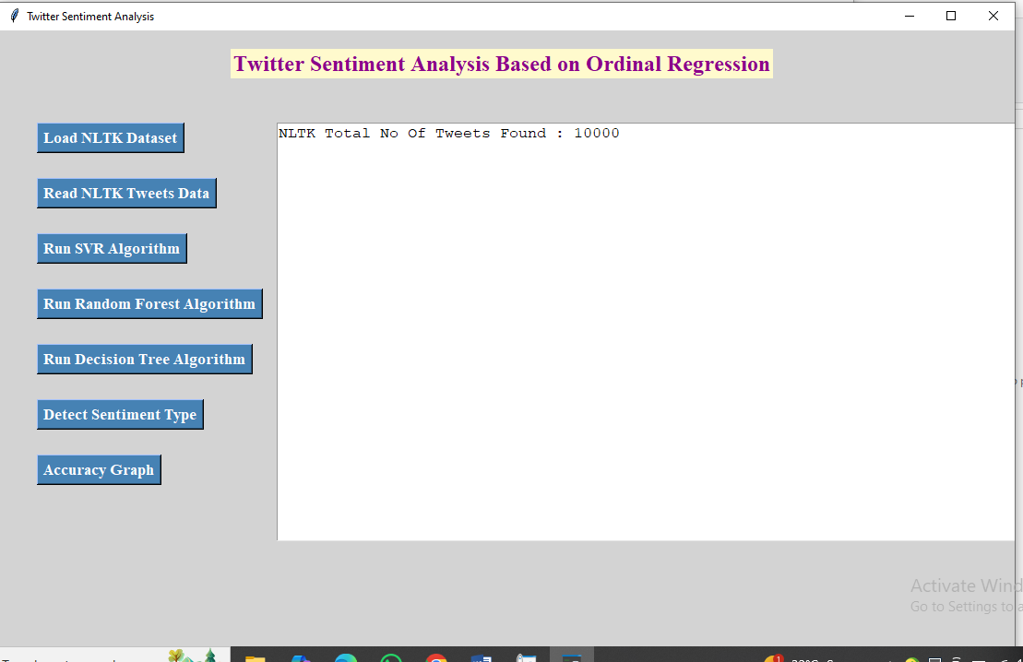

1. Now click on “Run SVR Algorithm” button.

NOTE: loading this button may consume time.

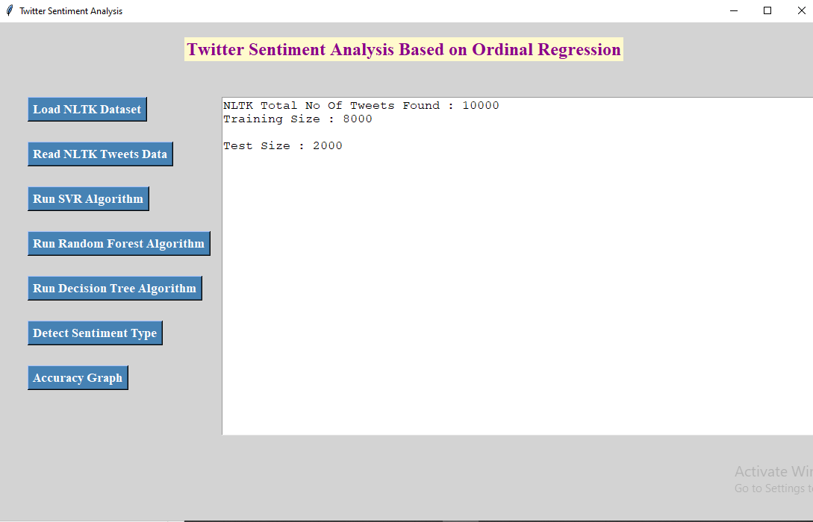

1. After running above button click on “Run random forest” button.

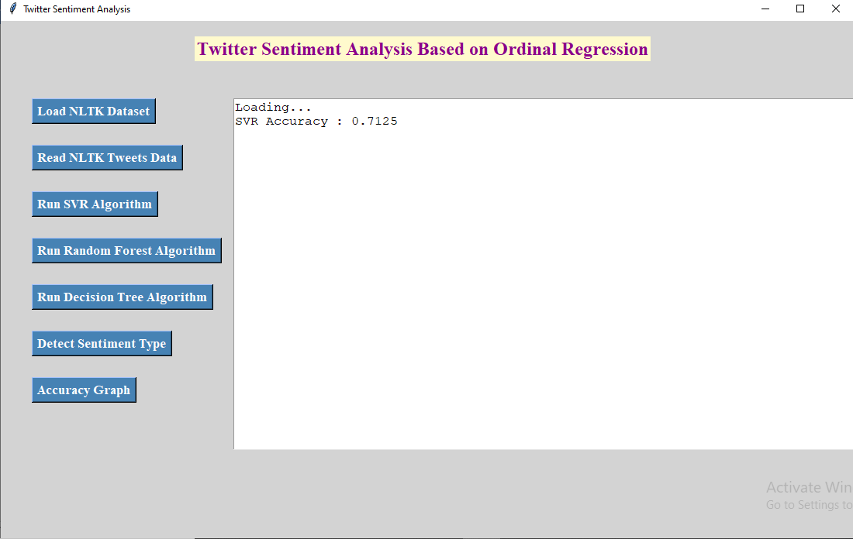

1. Next click on “Run decision tree algorithm” button.

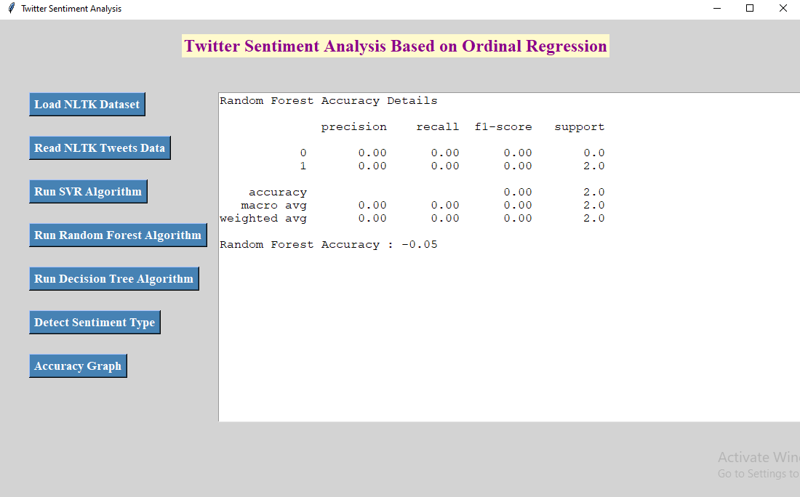

1. Click on detect sentiment type button.

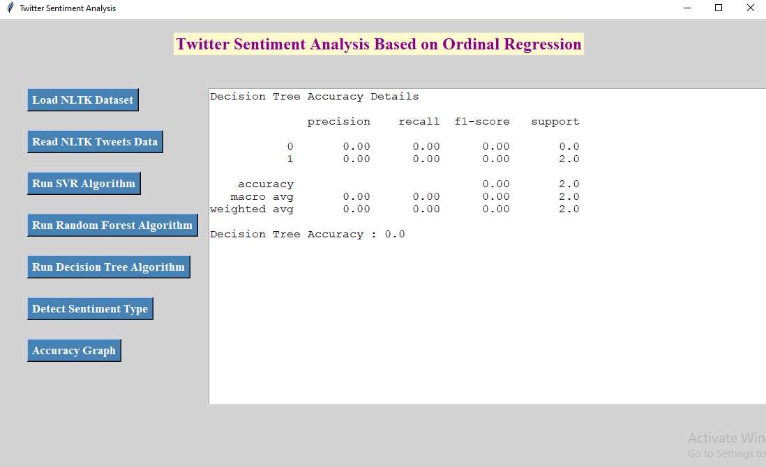

SELECT sample tweets:

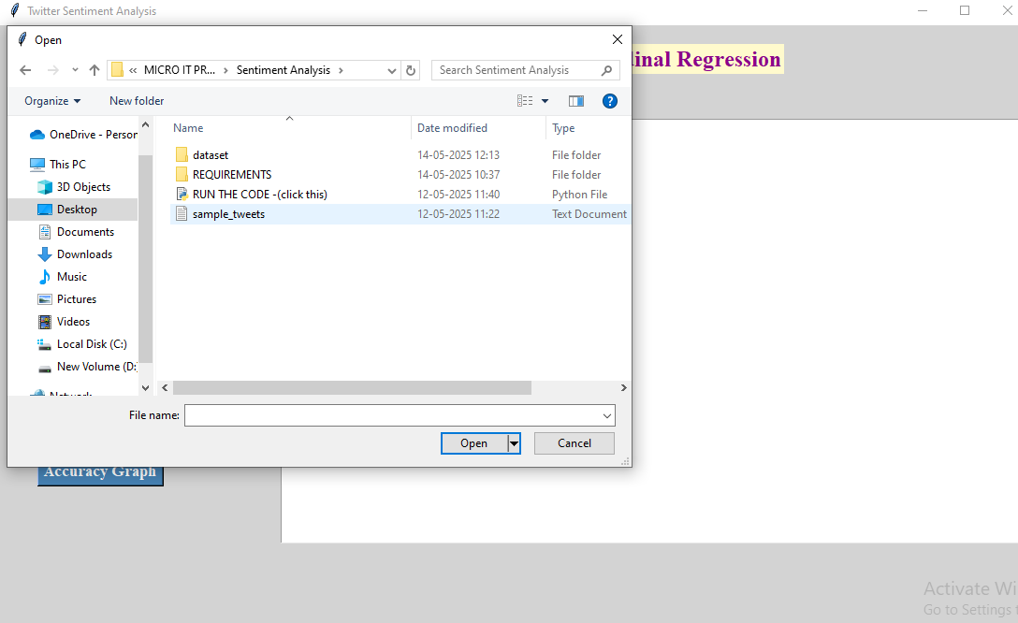

1. Click on “accuracy graph” button.

